ENGLISH 8 – WEEK 5

UNIT 3 : AT HOME

READ (SGK/31 32)

NEW WORDS
Safe (a) : an toàn => safety (n) : sự an toàn
Safety precaution ( n ) : Sự giữ gìn an toàn
Drug ( n ): Thuốc
Chemical ( n ): Hoá chất
Locked cupboard ( n ): Tủ có khoá
Match( es ) ( n ): que diêm, hộp diêm
Destroy ( v ) : Phá huỷ => destruction (n): sự phá huỷ
Injure ( v ) : Bị thương
Kill (v) : giết
Cause a fire: Gây ra hoả hoạn
Electrical socket ( n ) : ổ cắm điện
Electricity (n) : điện
Scissors ( n ) : cái kéo
Bead ( n ) : hạt (từ chuỗi hạt)
Dangerous (a) : nguy hiểm
Household objects (n) : đồ gia dụng

GRAMMAR
- Must / Have to + V : phải ( mang ý bắt buộc)
You must cover electrical sockets because children can
put something into them.
- Must not (mustn’t ) : không được phép làm gì
Children mustn’t play in the kitchen
- Let someone do something : để / cho phép (ai đó) làm gì
You can let children play here

WRITE ( P 32, 33)

NEW WORDS
wardrobe (n) : tủ quần áo
folder ( n) : thư mục, túi hồ sơ
oven (n) : lò vi sóng
jar (n ) : keo, hủ , lọ
lighting fixture (n) : đèn chùm
towel rack (n): giá treo khăn
vase ( n): lọ , bình ( cắm hoa)
=> Vase with flowers : bình hoa
above # beneath

Note
- Dùng “ There is a/ an + danh từ số ít …”, “ There are + danh từ số nhiều…” để diễn tả có một hay nhiều thứ gì đó.
- Muốn tả vị trí của đồ vật ta dùng các giới từ như: in, on, on/ to the left ( right) of, opposite, in the middle of, on the other side of, at the (right/ left) corner, beside, above, beneath . . .
Ex: There is a book on the table
Ex: There are some students in the classroom.
Ex: On the other side of the room, there is a window.
_______________________________________________________________________

PHẦN HƯỚNG DẪN TỰ HỌC TRONG SÁCH GIÁO KHOA
(Unit 3: AT HOME)

LISTEN AND READ (SGK/ 27 -28)
New words
- steamer (n): nồi hấp, nồi đun hơi
- cooker (n): nồi nấu cơm
Task 2. Read the dialogue again. Complete the list of the things Nam has to do.
(Hãy đọc lại hội thoại và viết ra những việc Nam phải làm.)
Answer key (Lời giải chi tiết):
- cook the dinner
- go to the market to buy fish and vegetables
- call Aunt Chi and ask her to meet his mother at his Grandma’s house.

SPEAK (SGK / 28-29)

Look at the picture. Work with a partner. Talk about the position of each item (Hãy nhìn tranh. Hãy cùng bạn em nói về vị trí của mỗi đồ vật.)
Task 1. Look at the picture. Work with a partner. Talk about the position of each item.
(Hãy nhìn tranh. Hãy cùng bạn em nói về vị trí của mỗi đồ vật.)
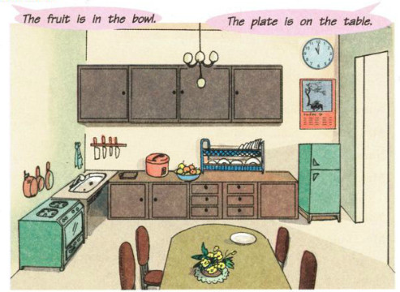

New words
- counter (n): kitchen counter (n) : mặt bếp, kệ bếp
- beneath (prep, adv): dưới, phía dưới
- vase (n): bình hoa
- dish rack( n) : kệ khăn
- calendar ( n) : lịch

Answer key (Lời giải chi tiết):
- The table is in the middle of the kitchen.
- The flowers are on the table.
- The plate is on the table near the flowers.
- The clock is on the wall above the refrigerator.
- The cupboard is on the wall above the counter.
- There are some knives on the wall under the cupboard.
- The rice cooker is on the counter near the dish rack.
- The bowl of fruit is on the counter next to the dish rack.
- The calender is on the wall above the sink.
- The sink is next to the stove.
- The saucepans and the frying pan are above the stove and the sink.

Task 2. Mrs. Vui bought new furniture for her living room, but she cannot decide where to put it. Work with a partner and arrange the furniture. You must reach an agreement.
(Bà Vui mua đồ gỗ mới cho phòng khách nhà bà nhưng bà không biết nên đặt chúng ở đâu. Em hãy cùng bạn em sắp xếp những đồ gỗ này. Các em phải thống nhất ý kiến với nhau.)

New words
- rug (n) : tấm thảm
- cushion ( n) : gối, đệm
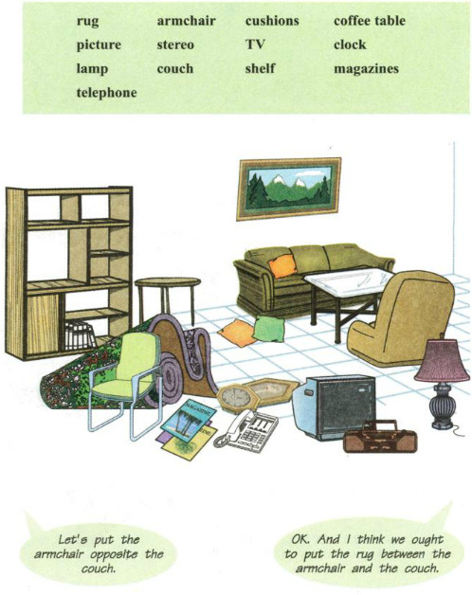

Answer key(Lời giải chi tiết):
A: Let’s put the couch against the wall.
B: OK. I think we ought to put the armchair opposite the couch.
A: OK. And I think we ought to put the coffee table between the armchair and the couch. How about the rug?
B: I think we ought to put it on the floor under the coffee table.
A: Good idea! Let’s hang the picture on the wall above the couch.
B: OK. And I think we ought to put the lamp in the corner next to the couch.
A: How about the shelves?
B: I think the shelves ought to be on the wall opposite the couch.
A: Great! And I think the TV and the stereo should be on the opposite wall across from the shelves.
B: Let’s hang the clock on the wall to the left of the picture.
A: I think we should hang it on the wall above the shelves.
B: OK. Let’s put the telephone on one of the shelves. How about the cushion?
A: I think we should put them on the couch.
B: Let's put the magazine on the coffee table.
A: OK.

